Travis St Lawrence CE Primary School
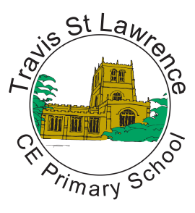
DT Long term plan

 | Autumn | Spring | Summer
Foundation | Children in EYFS access DT in line with the Expressive Arts and Design requirements of the National Framework for Early Years Foundation Stage.
Year 1 | Mechanism- Sliders and Levers  (making a moving storybook) | Structures- Freestanding structures  (making a windmill) | Mechanism- Wheels and axles  (making a vehicle)
Year 2 | Textiles-  Templates and joining techniques  (pouches) | Mechanisms- Sliders and Levers  (Moving monster) | Food and Nutrition  (balanced diet)
Year 3 | Mechanical systems  (Pneumatic toys) | Textiles-  (Cross stitch) | Structures  (Constructing a castle)
Year 4 | Electrical systems- simple circuit and switches  (torches) | Food and Nutrition  (Adapting a recipe) | Mechanical systems  (making a slingshot car)
Year 5 | Structures  (Frame structures- bridges) | Mechanical systems  (gears and pulleys) | Food and Nutrition-  (Developing a recipe)
Year 6 | Textiles-  (combining different fabric shapes) | Electrical systems- more complex switches and circuits  (steady hand game) | Mechanical systems-  (CAMHS and Automata toys)

