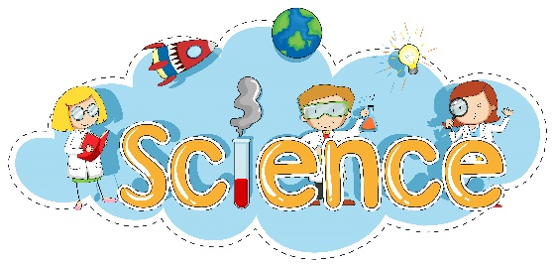
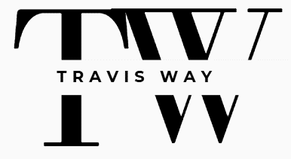
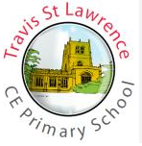
Impact: Monitoring
- Books looks, LTPs, MTPs checked
- Lesson drop ins
- Pupil voice
Impact: Evidencing
- Knowledge organisers in all science books for all science units.
- Written outcomes recorded in science books.
- Non-written outcomes sometimes recorded using photographs or videos.
Impact: Assessment
- Retrieval tasks
- Dictated sentences using key knowledge
- Use of discussion during lesson to monitor learning and used for AfL
- Pre/ of unit task /end of unit quiz
- Cover page with opportunities for children to add to growing knowledge/concepts.
- For every class, the teacher records who is on track and working towards (Insight)
Intent:
- Fulfils the National Curriculum
- Fully inclusive
- Links to our community where possible
- To equip pupils with the disciplinary skills and substantive knowledge to think like scientists.
- To embed careers into lessons, helping pupils see how their learning connects to real-world contexts.
Teaching aims:
- Inspire pupils’ curiosity and interest about the world.
- Developing both scientific knowledge and practical skills.
- Challenging misconceptions and uncovering the truth.
- Promoting critical thinking and the ability to ask good questions and analyse evidence.
- Using scientific vocabulary to boost understanding and communication.
- Practical activities where possible to create excitement and build scientific thinking.
- Lessons sequenced to ensure progression across year groups, enabling pupils to build and retain knowledge over time.
- Recap prompts, AfL questions and topic threads are embedded throughout, ensuring continuity and reinforcement.
- Cross-curricular links to literacy, maths, art, design and technology and other subjects are included where appropriate and helpful.

Implementation – Curriculum links
The curriculum builds a strong foundation in biology, chemistry and physics, while also teaching key scientific skills.
Key areas: Plants; Animals, including humans; Living things and habitats; Materials; Energy; Forces; Earth and space.

Implementation – What will you see in lessons?
- Knowledge organisers being used
- Previous learning being visited – retrieval tasks/discussion prompts.
- Engagement from all learners
- Children practicing skills – working like scientists (disciplinary knowledge)
- Collaborative discussions/ activities
- Classroom environment – display of current unit appropriate for that year group, key vocabulary displayed
- An environment where children can ask questions and share their view point
- Children making links with other areas of science.
Resources:
- Developing Expert Subscription
- Each lesson includes a full set of teaching resources: presentations, plans, quizzes, Books linked to the topic
- First hand experiences/outdoors
- Visitors into school
- Visits where possible
- Scientific equipment
Implementation - planning
- Long term plan that covers the NC and tailored towards our children’s needs and the local area.
- Teachers adapt schemes where appropriate and create medium term plans for each unit.

