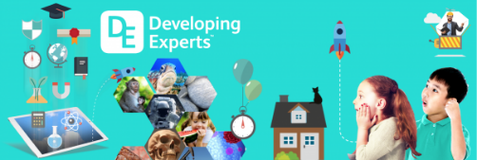
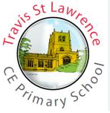
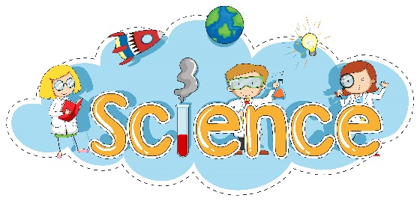
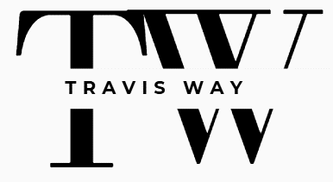
Impact: Assessment
- Retrieval tasks at the beginning of every lesson
- Dictated sentences with key information
- Use of discussion during lesson to monitor learning and used for AfL
- Pre/ of unit task /end of unit quiz
- Cover page with opportunities for children to add to growing knowledge/concepts.
- For every class the teacher records who is on track and working towards (Insight)
Resources:
- Developing Expert Subscriptions
- Books linked to the topic
- Websites
- Visitors into school
- Visits where possible

Impact: Evidencing
- Knowledge organisers in all science books for all science units
- Written outcomes recorded in science books
- Non-written outcomes recorded using photographs or videos.
Intent:
- Full fills the NC
- Fully inclusive
- Links to our community where possible
- Builds on previous scientific knowledge and skills
- Topic specific vocabulary
Teaching aims:
- Children develop a chronologically secure knowledge of local British and worldwide history
- Explicit teaching of significant people and events
- Inspire pupils’ curiosity and interest so they ask scientific valid questions
- Use a range of sources – primary: artefacts, written documents, photographs
- Secondary sources: books, videos, websites
- For children to reflect on cause and consequence and create their own viewpoint
- Understand the impact and significance of events and how it has impacted on our world today.
Impact: Monitoring
- Books looks – to ensure all follow the school’s LTP
- Lesson drop ins
- Pupil voice
Implementation - planning
- Long term plan that covers the NC and tailored towards our children’s needs and the local area.
- Teachers adapt schemes where appropriate and create medium term plans for each unit.
Implementation – What will you see in lessons?
- Knowledge organisners being used
- Previous learning being visited – retrieval task at the start
- Engagement from all learners
- Children practicing skills – working like scientists (disciplinary knowledge)
- Collaborative discussions/ activities
- Classroom environment – display of current unit appropriate for that year group, key vocabulary displayed
- An environment where children can ask questions and share their view point
- Children making links with other science topics
Implementation – Curriculum links
Our key concepts/strands are:
- Invasion and Empire
- Settlements and social history
- Monarchy and religion
- Exploration and travel

